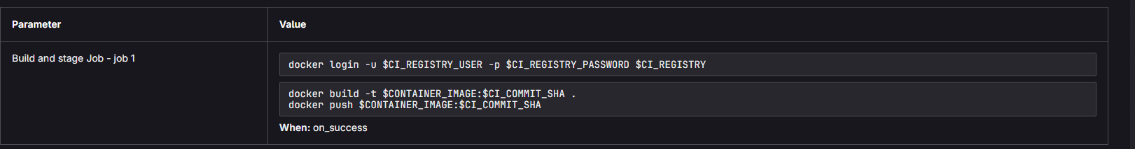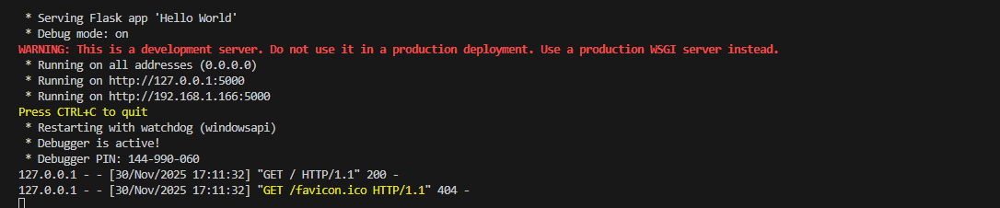

I’m not sure if I fully understood what I was needed to be submitted but this is my best attempt

